Use the following information to determine where pelicans living on Gunnison Island go to forage. Use the information in the table to determine the places that the following six pelicans went to for food.

Types of Fish in Freshwater Locations
Location | Type of Fish
Bear River Migratory Bird Refuge | carp, gizzard shad, crappie, chub
Farmington Bay | catfish, walleye, bass, weather loach, carp
Strawberry Reservoir | sucker, chub, cutthroat trout
Utah Lake | catfish, carp, sucker, bass, crappie, chub, walleye

Images of Fish
bass 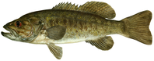 | gizzard shad 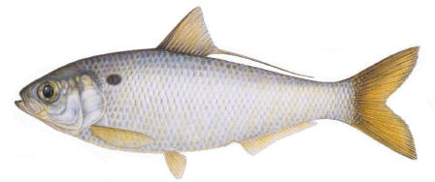
carp 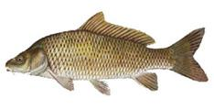 | sucker 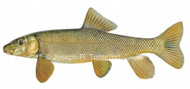
catfish 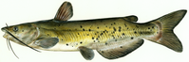 | cutthroat trout 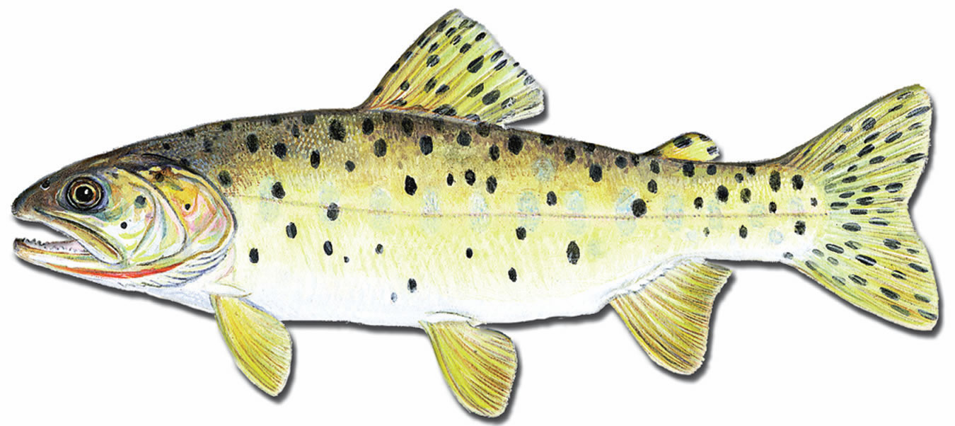
chub 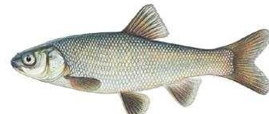 | walleye 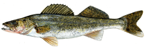
crappie 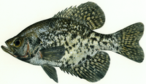 | 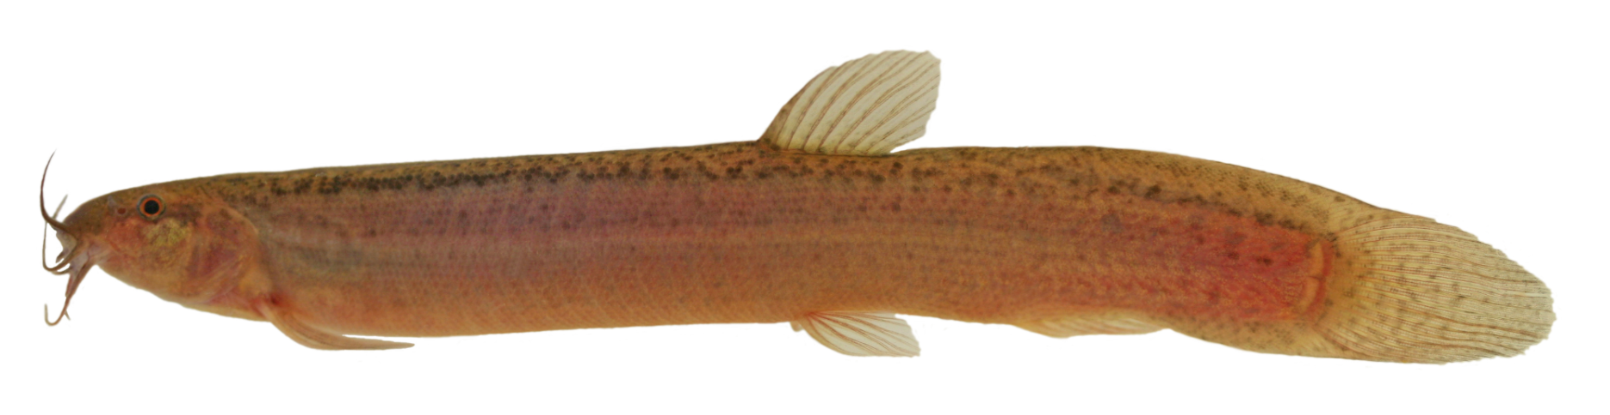  weather loach
Image Sources: https://www.nps.gov/media/photo/gallery.htm?id=62047290-155D-451F-67600E347A2E22DF, http://www.bigfishtackle.com/, http://fieldguide.mt.gov/speciesDetail.aspx?elcode=AFCJB13020, https://commons.wikimedia.org/wiki/File:Bonneville_Cutthroat_Trout_(6878987882).jpg, http://www.americanfishes.com/, http://staff.royalbcmuseum.bc.ca/2015/01/12/who-will-know-where-loaches-go/

Regurgitated Food Pile #1:

Regurgitated Food Pile # 2:

Regurgitated Food Pile # 3:

Regurgitated Food Pile # 4:

Regurgitated Food Pile # 5:

Regurgitated Food Pile # 6:

Key:

Pile #1: Utah Lake
Pile #2: Strawberry Lake
Pile #3: Farmington Bay
Pile #4: Utah Lake
Pile#5: Bear River
Pile#6: Bear River

