Science
Fair
Handbook
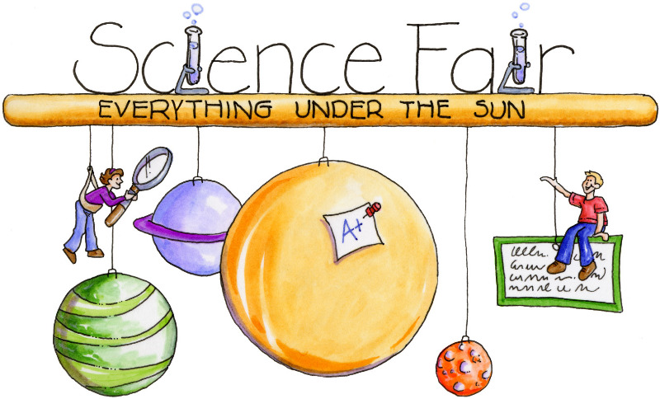
Name _______________
Science Fair Schedule
Assignment | Due Date
6.2.4 Design an object, tool or process that minimizes or maximizes heat energy transfer. Identify criteria and constraints, develop a prototype for interactive testing, analyze data from testing and propose modifications for optimizing the design solution.  *Design an experiment that follows the standard. Make sure that you document the process as you go.  Complete worksheet 1. | December 13, 2018
Complete worksheet 2. | December 20, 2018
Complete worksheet 3 & 4  (conduct your experiment!) | January 3, 2019
Complete worksheet 5  & put board together. | January 7, 2019
Present project to the class. | January 8, 2019

Worksheet 1
Choosing & Researching Your Project

Question: Your question should be about maximizing heat energy transfer or minimizing heat energy transfer. It should relate to your world, something you want to find the answer to.
___________________________________________________________
____________________________________________________________

Approved: __________
Not Approved: __________
Materials: What materials will you need to complete your project?
1. Tri-fold board
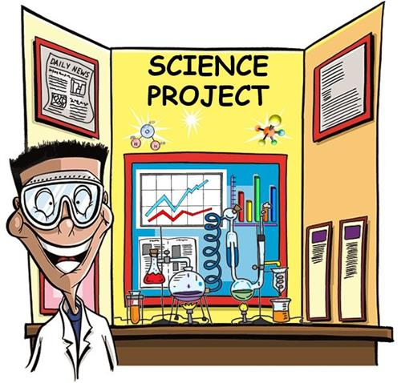
2. _________________________________
3. _________________________________
4. _________________________________
5. _________________________________
**Remember only your board and notebook will be brought to school.
Research: Find 2-3 sources that will help you understand your topic. Create a bibliography below for the resources:
1. ____________________________________________________________
2. ___________________________________________________________
3. ___________________________________________________________
Worksheet 2
Research, Hypothesis, & Procedure
Research: What did you learn about your topic?
______________________________________________________________
______________________________________________________________
______________________________________________________________
___________________________________________
___________________________________________

Hypothesis: AFTER reading your research, what is your hypothesis (what do you predict will happen as you experiment?)
______________________________________________________________
______________________________________________________________
Procedure: List the steps you will take and/or the supplies you will need to conduct your experiment:
1. ____________________________________________________________
2. ___________________________________________________________
3. ___________________________________________________________
4. ___________________________________________________________
5. ___________________________________________________________
6.____________________________________________________________
7. ___________________________________________________________
Worksheet 3
Use a Graph to Gather Data

Data: What is your constant (the “thing” that is the same in each
test)? _______________________________________________________
What is your variable (the “thing” that is different in each test)?
______________________________________________________________

Graph: All data needs to be tracked on a graph. You may use the one below or create one of your own.

Worksheet 4a
Understanding your Data
After you have finished experimenting, explain what you noticed.
______________________________________________________________
______________________________________________________________
______________________________________________________________
______________________________________________________________
Worksheet 4b
Writing your Conclusion
Write a conclusion for your science fair project. Was your hypothesis correct? Why or why not? What did you learn?
______________________________________________________________
______________________________________________________________
______________________________________________________________
______________________________________________________________
*Presentation*
Make sure that your tri-fold board includes a title and ALL
the information in this packet (typed). If your project is
sent on to the district science fair, you will need to make a
power point or google slide show. It just makes sense to
type all of your information the first time around, right??? PLEASE PUT YOUR NAME ON THE BACK OF YOUR BOARD!

